

**KABARAK UNIVERSITY**

**IT PROJECT II**

**LOCATION-BASED ADVERTISEMENT APP**

**JOHN NYANGALA NGOTO**

**BBIT/MG/1130/09/21**

**This is a research submitted to the institute of undergraduate and research in the fulfillment of requirements for the awarding of the degree in Bachelor of Business and Information Technology (B.B.I.T) at Kabarak University, Nakuru County.**

**MAY-AUGUST 2025.**

<https://github.com/Johnnie-tez/Quickfind.git>

**DECLARATION**

I hereby declare that the project presented before you is as a result of my own research and has not been presented before for any other degree or examination whatsoever at any institution. All sources of information to facilitate this research have been dully acknowledged knowing the penalties and consequences that arise due to plagiarism as it is not according to the institutions policies.

JOHN NYANGALA NGOTO

Signature…………………….. Date………………………….

Mr. CLEOPHAS MOCHOGE

Signature……………………... Date…………………………..

**ACKNOWLEDGEMENT**

I would first direct my gratitude to the most high for the gift of life he granted me throughout this research proposal period. All this would have never been possible without his helping hand. I would secondly like to thank the administration for the opportunity to put our research skill to the ultimate test by enabling us to venture in to this project. The resources they poured to facilitate this proposal and those for my fellow students has not been put to waste as the research was a success thanks to them. I would also direct my gratitude to our supervisor, the esteemed Mr. Simon Ruoro for his never ending dedication and guidance throughout this research period as he dedicated his time to carefully check for mistakes and corrected where there were some. Working under his supervision was a true revelation to me thus the need to be thankful.

I would also like to thank my parents for their unwavering love and support to where I am today. They provided me with the necessary conditions to be here and just a thank you won’t be enough to pay for the sacrifices they gave for me to be where I am today. It wasn’t easy to be where I am today also if it wasn’t for the friends who pushed me forward and I would give a massive shout out to them. Lastly, I would thank myself for the sheer commitment I put into this. It wasn’t easy but it’s true what they say that the end justify the means and the end was fruitful therefore it was quite a journey.

**ABSTRACT**

This research delves into the inefficiencies of contemporary advertising, exploring how a location-based advertisement (LBA) mobile application can offer a more effective solution. The current advertising landscape is plagued by irrelevant content, information overload, and privacy issues. Users are bombarded with advertisements that hold little value to their immediate needs, and are irrelevant to their immediate location, leading to frustration and a decline in advertisement engagement.

This research investigates the design and development of a mobile application that leverages location-based services (LBS) to deliver targeted advertising to users. The primary objective of the mobile application is to provide the user with necessary advertising information by delivering targeted advertisements of goods and services he/she may be looking for based on a user's real-time location. The proposed application will utilize a combination of GPS and user profile data to pinpoint a user's location and present them with advertisements for products or services in their immediate vicinity. However, the success of this LBA application hinges on addressing user privacy concerns. The research explores robust methods for ensuring user data is collected and utilized responsibly. Transparency and user control over data collection are paramount to building trust and encouraging user adoption. This research contributes significantly to the field of mobile marketing by proposing a paradigm shift in advertising strategies. LBA technology has the potential to revolutionize the industry by creating a mutually beneficial ecosystem for both users and advertisers. Users receive relevant and timely promotions, while advertisers gain access to a highly targeted audience, ultimately leading to a more effective and efficient advertising landscape.

Table of Contents

CHAPTER ONE 8

INTRODUCTION 8

1.1 BACKGROUND OF STUDY 8

1.2 PROBLEM STATEMENT 9

1.3 PURPOSE OF THE STUDY 11

1.4 STATEMENT OF ABJECTIVES 11

1.4.1 MAIN OBJECTIVE 11

1.4.2 SPECIFIC OBJECTIVES 11

1.5 RESEARCH QUESTIONS 11

1.6 PROPOSED SYSTEM AND SYSTEM MODULES 12

1.6.1 PROPOSED SYSTEM 12

1.6.2 SYSTEM MODULES 14

1.7 JUSTIFICATION OF STUDY 14

1.8 FEASIBILITY STUDY 15

1.9 SCOPE AND LIMITATION OF STUDY 16

1.9.1 SCOPE OF STUDY 16

1.9.2 LIMITATIONS OF STUDY 16

CHAPTER TWO 18

LITERATURE REVIEW 18

2.1 INTRODUCTION 18

2.2 GENERAL OVERVIEW OF THE TOPIC 19

2.3 USER INTERFACE (UI) DESIGN FOR LOCATION-BASED APPS 20

2.4 UNDERSTANDING USER BEHAVIOUR IN UNFAMILIAR ENVIRONMENTS 21

2.5 FEATURE SELECTION TECHNIQUES FOR IMPROVED USER EXPERIENCE 22

2.6 PERSONALIZATION THROUGH USER PROFILES AND MACHINE LEARNING 23

2.7 EVALUATION OF RECOMMENDED ALGORITHMS 23

2.8 CONCLUSION 24

CHAPTER THREE 25

RESEARCH DESIGN AND METHODOLOGY 25

3.1 RESEARCH DESIGN 25

3.1.1 QUALITATIVE METHODS 25

3.1.2 QUANTITATIVE METHODS 26

3.2 LOCATION OF THE STUDY 26

3.3 POPULATION OF THE STUDY 27

3.4 SAMPLING PROCEDURE AND SAMPLING SIZE 27

3.5 DATA COLLECTION PROCEDURE 28

3.5.1 QUALITATIVE DATA 28

3.5.2 QUANTITATIVE DATA 28

3.6 SYSTEM DEVELOPMENT METHODOLOGY 28

3.7 SYSTEM ANALYSIS AND DESIGN 29

3.7.1 CONTEXT DIAGRAM 30

3.7.2 USE CASE DIAGRAM 32

3.7.3 DATA FLOW DIAGRAM (D.F.D) 33

3.7.4 DATABASE DESIGN 35

3.7.5 ER DIAGRAM 36

3.7.6 ARCHITECTURAL DESIGN 37

3.8 CONCLUSION 37

CHAPTER FOUR 39

SYSTEM IMPLEMENTATION AND DEPLOYMENT 39

4.1 INTRODUCTION 39

4.2 DEVEVELOPMENT AND SOFTWARE SETUP 39

4.3 IMPLEMENTATION STEPS 41

Step-by-step implementation plan. 41

The system was implemented by following the steps below: 41

4.4 TESTING AND QUALITY ASSURANCE 42

4.5 DEPLOYMENT PLAN 42

4.6 GO-LIVE PLAN 42

4.7 MAINTAINANCE AND SUPPORT 42

4.8 CONCLUSIONS AND FUTURE WORKS 43

Conclusions 43

Future Works 43

APPENDICES 46

Table of Figures

Figure 1: context diagram 30

Figure 2: use case diagram 32

Figure 3: a data flow diagram 33

Figure 4: database design 1 34

Figure 5: database design 2 34

Figure 6: database design 3 35

Figure 7: database design 4 35

Figure 8: ER diagram 35

Figure 9: architectural design 36

# CHAPTER ONE

# INTRODUCTION

## BACKGROUND OF STUDY

In the past, finding local products meant physically going from store to store. The rise of the internet brought online shopping, but it lacked the immediacy of finding something nearby. The challenge lies in bridging that gap: leveraging technology to connect users with physical stores that have what they need, right when they need it Smith, J. (2022). Imagine being in a completely new location and you have to endure the difficulty of finding a certain product or service that you may need at that time. For example, if you are exhausted and need a place to lay in for the night, you might struggle to find the nearest lodging just because you aren’t familiar with the surrounding area. Here are some of the challenges you may face:

**Navigation Issues:** Unfamiliarity with the layout of stores or the surrounding area can make it difficult to find what you're looking for. Even if you know the product exists, navigating a foreign store can be a challenge Johnson, L. (2021).

**Frustration Issues:** You may get frustrated due to the fact that you are exhausted in the first place and you've marched into unchartered territory with no way of navigating the place Brown, D. (2020).

**Language Barriers:** Signs, menus, and spoken language might be unfamiliar, making it difficult to find what you need. You may not even speak the same language with the locals, making it even harder Lee, M. (2019).

These issues necessitate a paradigm shift in advertising strategies. Consumers crave a more personalized and relevant experience, and advertisers seek methods to reach qualified audiences with greater efficiency Adams, R. (2023).

While advancements in online advertising, such as behavioral targeting and contextual advertising, have attempted to address these concerns, they often rely heavily on user data collection practices that can be intrusive and opaque Chen, P. (2022). This can lead to a feeling of unease among users, who may perceive their online activity being constantly monitored and exploited Miller, S. (2021).

This research proposes a novel solution: a location-based advertisement (LBA) mobile application. This approach offers a unique opportunity to deliver highly relevant and timely advertisements to users based on their real-time location Wang, Q. (2023), potentially mitigating privacy concerns through responsible data collection practices Gupta, A. (2020). It will also bring some sense of familiarity with the place and will enable one to have a slight idea of where the product/service he/she is looking for is located. By leveraging location data with user consent and transparency, LBA technology has the potential to revolutionize the advertising landscape, creating a mutually beneficial ecosystem for both users and advertisers. Users receive relevant advertisements that enhance their daily lives, while advertisers gain access to a highly targeted audience, ultimately leading to a more effective and efficient advertising landscape Davis, E. (2024).

## PROBLEM STATEMENT

Imagine you're traveling to a new city for a business trip or vacation. You're unfamiliar with the area and need to find essential services like restaurants, places to rest for the night, grocery stores, ATMs, or even local attractions. Navigating a new environment can be stressful, and the time spent searching for these basic needs can quickly eat into your itinerary. You might find yourself:

Wasting time searching online or asking strangers for recommendations which in turn leads to frustration and delays.

End up at inconvenient or overpriced options because you lack local knowledge.

Miss out on hidden gems and unique experiences the area has to offer.

There's a need for a way that leverages a user's location to provide contextually relevant information on nearby products and services. It should address the following:

Real-time discovery: Provide immediate recommendations based on the user's current location and needs.

Personalized suggestions: Go beyond generic listings by considering user preferences and past behavior.

Seamless user experience: Offer a user-friendly interface with clear information and easy navigation tools.

By solving these problems, this location-based advertisement app can connect users with the products and services they need, enhancing their experience in unfamiliar locations. Imagine strolling down a bustling street and instantly discovering a charming cafe with outdoor seating, perfect for a refreshing break. Or, picture yourself navigating a maze-like airport with the app guiding you straight to the nearest ATM. This app can be your trusted companion, transforming the stress of exploring a new place into an exciting adventure of discovery. Not only will it help you find what you need, but it can also introduce you to hidden gems you never knew existed, from authentic local eateries to unique cultural experiences. With this app by your side, you can make the most of your time in any new location, ensuring a smooth, enjoyable, and unforgettable experience.

## PURPOSE OF THE STUDY

The purpose of the study would be to bridge the gap between a user's needs in a new location and the effectiveness of location-based advertising apps in fulfilling those needs. This research would inform the design and development of future apps that can seamlessly integrate into a user's journey, transforming the experience of exploring unfamiliar places.

## STATEMENT OF ABJECTIVES

### MAIN OBJECTIVE

The main objective of the study would be to develop a location-based advertising app that revolutionizes how users discover and navigate through products and services in new and unfamiliar locations.

### SPECIFIC OBJECTIVES

1. To provide real-time, contextually-relevant recommendations based on a user's current location and personalized preferences.
2. To create an app that reduces the time users spend searching for products and services in new locations.
3. To provide data security for the user including disclosing their location only to the people of their liking.

## RESEARCH QUESTIONS

1. How will the application provide real-time, contextually-relevant recommendations based on a user's current location and personalized preferences?
2. How will the application reduce the time users spend searching for products and services in new locations?
3. Will the application also provide data security for the user including disclosing their location only to the people of their liking?

## PROPOSED SYSTEM AND SYSTEM MODULES

### PROPOSED SYSTEM

This system outlines a mobile app that leverages location-based services and user data to provide users with a seamless and personalized experience in finding products and services in new and unfamiliar locations with a specific radius.

**Core Components:**

**Mobile App:**

A user-friendly interface with map visualization and search functionalities.

Location tracking capabilities using GPS or cell tower data.

User profile creation for personalization.

**Functionalities:**

Location Detection: Upon launch, the app utilizes GPS or cell tower data to pinpoint the user's current location.

Search Functionality:Users can search for specific products, services, or business names. Autocomplete feature for faster and more efficient search based on user search history.

Contextually Relevant Results:The app prioritizes results closest to the user's current location. Recommendations and search results are filtered based on user preferences (if enabled).Rich information displayed for each result, including ratings, reviews, photos, and opening hours.

Navigation and Routing:Users can seamlessly navigate to chosen locations using integrated mapping services. The app provides turn-by-turn directions to ensure a smooth journey.

User Feedback and Review System:Users can leave reviews and ratings for businesses, contributing to the overall recommendation accuracy.

**Benefits:**

Reduced decision-making time: Users can quickly find what they need thanks to personalized recommendations and efficient search functionalities.

Increased user satisfaction: Relevant suggestions based on user preferences and location lead to a more positive user experience.

Improved business visibility: Local businesses gain exposure to a targeted audience looking for their products and services.

Personalized user experience (optional): User profiles allow for fine-tuned recommendations that cater to individual needs.

### SYSTEM MODULES

Here's a breakdown of the proposed location-based advertising app system into modules:

**User Interface (UI) Module**

This module handles everything users see and interact with on the app and below are some of the key functionalities:

Location display using maps.

Search bar for finding specific products or services.

Browsing and filtering options for recommendations.

Navigation features including turn-by-turn directions.

User feedback and review system.

**Location Tracking Module**

This module is responsible for pinpointing the user's current location which in this case utilizes:

GPS for precise location data, that is, if it’s available.

Cell tower triangulation for less precise location data (as a backup).

## JUSTIFICATION OF STUDY

Despite the existence of location-based advertising apps, there's a need for a more user-centric approach that prioritizes efficiency, personalization, and a seamless user experience. This study aims to bridge the gap between current app functionalities and user needs in unfamiliar environments. The importance of the research cannot be overstated because firstly existing apps might prioritize business promotion over user experience. This study delves into user frustrations and time wasted searching for basic necessities in new locations. Secondly, generic recommendations often miss the mark. This study explores how user profiles and machine learning can personalize suggestions, catering to individual needs and preference and lastly, finding desired products and services can be cumbersome. This study investigates how to optimize search functionalities and user interface design for faster and more intuitive navigation. So, in conclusion, this research has the potential to revolutionize how people navigate unfamiliar locations, making it easier and faster to find what they need. It can also benefit businesses by connecting them with a targeted audience actively looking for their offerings. This research not only addresses a specific user need but also contributes to the development of more user-friendly and intelligent mobile applications.

## FEASIBILITY STUDY

This feasibility study assesses the viability of developing a location-based advertising app based on the proposed system and the identified market gap. The market for location-based advertising is booming, with users increasingly relying on mobile apps to find products and services nearby. Existing apps often prioritize advertising over user experience. This app addresses the user pain points of wasted time in searching for products due to unfamiliarity with location.

The app can generate revenue through in-app advertising or premium features. Local businesses will likely be interested in advertising to a targeted audience actively seeking their services. App development costs can vary depending on complexity. However, the use of existing technologies and a well-defined scope can keep costs manageable.

**Overall, the development of a location-based advertising app with a strong focus on user experience appears to be feasible.** The market demand is high, the technology exists, and the potential for revenue generation is promising. Careful planning and execution are necessary to manage development costs and ensure user privacy.

## SCOPE AND LIMITATION OF STUDY

### SCOPE OF STUDY

This study focuses on developing a location-based advertising app that prioritizes a user-centric experience for finding products and services in unfamiliar locations. Here's what the study will cover:

**Understanding User Needs:** Through user surveys, interviews, and task analysis, the study will identify user pain points and challenges in finding what they need in new places. It will examine decision-making processes, time spent searching, and the level of frustration with current solutions.

**Optimizing User Interface (UI) Design:** The study will explore how to design a user-friendly interface that facilitates quick searches, clear information display, and easy navigation. Usability testing will be conducted to ensure the interface is intuitive and efficient.

**Personalization through User Profiles (Optional):** This aspect will investigate the feasibility and effectiveness of user profiles for storing preferences (budget, dietary needs) and interests (attractions, activities). Machine learning algorithms will be explored to analyze user data and personalize recommendations based on these profiles.

**Evaluation of Recommendation Algorithms:** The study will compare different recommendation algorithms (content-based, collaborative filtering, or hybrid) to assess their accuracy and effectiveness in suggesting relevant products and services to users.

### LIMITATIONS OF STUDY

While the study aims to develop a comprehensive app, there are some limitations to consider:

**Focus on Specific User Groups:** The study might target a specific user demographic (e.g., young professionals, frequent travelers) during the initial phase. This might limit the generalizability of findings to a broader population.

**Data Availability and Bias:** The effectiveness of machine learning algorithms heavily relies on data quality and quantity. The study might need to address potential data limitations and identify methods to mitigate bias in recommendations.

**Offline Functionality:** Implementing comprehensive offline functionalities (e.g., saved locations with detailed information) might require additional development effort and storage capacity. This study might prioritize core functionalities with potential for limited offline capabilities in later stages.

**These limitations will be acknowledged and addressed throughout the research process.** By carefully considering these boundaries, the study can deliver valuable insights and a functional app prototype within its defined scope.

# CHAPTER TWO

# LITERATURE REVIEW

## INTRODUCTION

Finding the right products and services in unfamiliar locations can be a frustrating and time-consuming experience. Travelers, newcomers to a city, or anyone in this case venturing into unchartered territory often find themselves lost in a maze of unfamiliar streets and businesses. Existing location-based advertising apps, while promising in their ability to connect users with nearby offerings, often fall short in addressing the specific needs of users in these situations. Inefficient search processes can lead users down rabbit holes of irrelevant recommendations, wasting valuable time and leaving them feeling more overwhelmed than informed. While these apps offer the potential to streamline the process of finding what you need, the user experience often falls short, leaving users to resort to frustrating and time-consuming workarounds like consulting multiple online sources or asking strangers for directions.

In terms of app development in the past, there has been major breakthroughs in terms of coming up with an effective location based advertisement application over the years. Some key figures and companies have been instrumental in their development. Yelp, founded in 2004, and Foursquare, founded in 2009, was among first to introduce location based social networking which allow users to find and review businesses near their location. The integration of location-based features with search engines like Google Maps which was launched in 2005 played a major role in popularizing the concept. Google Maps allows users to search for businesses by location, see user reviews and ratings, and get directions. In later years, companies like Google AdMob which was founded in 2006 and Apple iAd launched in 2010 provided the infrastructure for location-based advertising within mobile apps. These platforms allow businesses to target users based on their location, making location-based advertising apps a viable revenue stream. One thing is clear though, location-based advertisement app are a constantly evolving field meaning many companies and researchers are contributing to their development, with a focus of improving user experience, personalization and the effectiveness of recommendation algorithms.

## GENERAL OVERVIEW OF THE TOPIC

The increasing prevalence of smartphones has fueled the rise of location-based advertising apps (LBAAs) (Grewal et al., 2020). These apps connect users with nearby businesses, offering a seemingly convenient way to find products and services on the go. However, a growing body of research suggests that current LBAAs often prioritize promoting businesses over user experience (Lee & Park, 2014). This user experience gap manifests in several ways such as generic suggestions that fail to consider user preferences can lead to frustration and wasted time (Huang et al., 2019) and unintuitive interfaces and search functionalities that, in turn, make it difficult for users to find what they need quickly (O'Brien & Mizobuchi, 2018).

For users navigating unfamiliar locations, such as travelers or newcomers to a city, these limitations can be particularly problematic. Studies by Wang and Li (2019) highlight how users in unfamiliar environments prioritize finding essential needs like restaurants and ATMs. However, they often resort to fragmented methods like online searches or asking strangers for directions, leading to inefficiencies (Tomitsch & Strauss, 2017).

Effective LBAAs require a user-centric design approach that prioritizes user needs and simplifies the search process. Research by Lazar et al. (2017) emphasizes key UI design principles for LBAAs:

Clarity and Simplicity: Clear information hierarchy and minimal clutter ensure users can easily understand and navigate the app (Rauschenberger & Gregor, 2008).

Seamless Search Functionality: Intuitive search options using keywords, categories, or location filters allow users to find what they need quickly (Silva et al., 2019).

Visual Appeal and Usability: A visually appealing interface with user-friendly features like clear icons and intuitive search bars enhances user experience (McGregor & Cockburn, 2004).

The potential for personalization through user profiles and machine learning algorithms offers a promising avenue for improving LBAAs. Adomavicius and Tuzhilin (2015) explore how user profiles storing preferences and interests can be leveraged to:

Predict User Needs: Machine learning algorithms can analyze user data and past behavior to anticipate their requirements in new locations (Wang et al., 2018).

Deliver Relevant Recommendations: By understanding user preferences (e.g., budget, dietary restrictions), recommendations can be tailored to their specific needs, saving them time and frustration (Jannach et al., 2015).

Discover Hidden Gems: Machine learning can identify unique experiences and hidden gems that align with user interests (e.g., cultural attractions, outdoor activities) (Bao et al., 2018).

The success of personalization hinges on the accuracy and effectiveness of the recommendation algorithms employed. Said et al. (2011) emphasize the importance of choosing algorithms that can handle diverse user data and preferences (Park et al., 2012). Additionally, user testing and feedback mechanisms are crucial for evaluating recommendation accuracy and identifying areas for improvement (Gunawardana & Shani, 2015). By continuously refining these algorithms based on user data and feedback (Ricci et al., 2015), LBAAs can move beyond simply connecting users with businesses and become valuable tools for navigating unfamiliar environments and discovering new experiences.

This chapter has provided a general overview of the topic, highlighting the need for a user-centric approach in location-based advertising apps. By focusing on user needs, clear interface design, and personalization through user profiles and machine learning, LBAAs have the potential to transform the user experience and empower users to explore unfamiliar locations with greater ease and efficiency.

## USER INTERFACE (UI) DESIGN FOR LOCATION-BASED APPS

The user interface (UI) plays a critical role in app success. Research by Lazar et al. (2017) emphasizes user-centered design principles:

Clarity and Simplicity: The interface should be easy to understand and navigate, with minimal clutter and clear information hierarchy for quick comprehension (Rauschenberger & Gregor, 2008).

Seamless Search Functionality: Search options should be intuitive, allowing users to find what they need quickly using keywords, categories, or location filters (Silva et al., 2019). Users accustomed to popular search engines will expect a familiar and efficient search experience within the app.

Visual Appeal and Usability: A visually appealing interface with user-friendly features like clear icons and intuitive search bars enhances user experience (McGregor & Cockburn, 2004). Pleasant aesthetics can motivate users to engage with the app more readily.

## UNDERSTANDING USER BEHAVIOUR IN UNFAMILIAR ENVIRONMENTS

Understanding how users behave when navigating unfamiliar environments is essential for designing effective LBAAs. Studies by Wang and Li (2019) employed user observation techniques to identify user behavior patterns. Their research revealed that users in unfamiliar locations prioritize finding essential needs such as restaurants, ATMs, or grocery stores (Wang & Li, 2019). They often resort to fragmented methods like conducting online searches on multiple platforms or asking strangers for directions, leading to inefficiencies and wasted time (Tomitsch & Strauss, 2017).

These findings suggest that LBAAs should focus on features that cater to these user behaviors. Here are some examples of features that can be prioritized through feature selection:

Location Filtering: A user-friendly and efficient location filtering functionality is crucial, allowing users to easily search for businesses within a specific radius around their current location.

Category Search: The ability to search by category (e.g., restaurants, ATMs, gas stations) can streamline the process for users who know what type of business they are looking for.

User Reviews and Ratings**:** Integrating user reviews and ratings can empower users to make informed decisions about which businesses to visit, especially in unfamiliar locations where they might lack local knowledge.

## FEATURE SELECTION TECHNIQUES FOR IMPROVED USER EXPERIENCE

Feature selection plays a vital role in optimizing LBAAs for user experience. Here's an overview of different feature selection techniques that can be employed to identify the most relevant features for LBAA recommendation algorithms:

Filter Methods: These techniques analyze the data itself to identify relevant features. Statistical tests like chi-square or correlation coefficients can help identify features with strong relationships to the target variable (businesses relevant to user needs) (Guyon & Elisseeff, 2003). For instance, a chi-square test could be used to identify a correlation between a user's selection of vegetarian restaurants in the past and the presence of the keyword "vegetarian" in a business description.

Wrapper Methods: These methods evaluate feature subsets based on their impact on a chosen machine learning model's performance. Techniques like forward selection or backward selection iteratively add or remove features based on their contribution to model accuracy in recommending relevant businesses to users (Jain & Chandrasekhar, 2019).

Embedded Methods: These methods incorporate feature selection within the model training process itself. Regularization techniques like L1 or L2 regularization penalize the coefficients of features during training. Features with coefficients driven to zero by the regularization process are likely not contributing significantly and can be removed (James et al., 2013)

## PERSONALIZATION THROUGH USER PROFILES AND MACHINE LEARNING

Personalizing the user experience can significantly improve app effectiveness. Adomavicius and Tuzhilin(2015) explore the potential of user profiles for storing preferences and interests. This information can then be leveraged by machine learning algorithms to:

Analyze user data and past behavior to predict future needs (Wang et al., 2018). By understanding a user's typical searches and past selections, the app can anticipate their requirements in a new location.

Recommend relevant products and services that align with user preferences (e.g., budget, dietary restrictions) (Jannach et al., 2015). This can help users avoid irrelevant suggestions and save them time in their decision-making process.

Identify hidden gems and unique experiences based on user interests (e.g., cultural attractions, outdoor activities) (Bao et al., 2018). Machine learning can go beyond simply recommending establishments and personalize the discovery of interesting places that align with a user's passions.

## EVALUATION OF RECOMMENDED ALGORITHMS

The accuracy and effectiveness of recommendation algorithms are crucial for user satisfaction. Said et al. (2011) compare different recommendation algorithms, such as content-based filtering, collaborative filtering, or hybrid approaches. This research highlights the importance of:

Choosing algorithms that can handle diverse user data and preferences (Park et al., 2012). The chosen algorithms should be adaptable to a wide range of user profiles and interests to ensure effective recommendations across a broad user base.

Evaluating the accuracy of recommendations through user testing and feedback mechanisms (Gunawardana & Shani, 2015). User feedback is essential to identify biases or limitations in the algorithms and refine them for improved accuracy.

Continuously refining the algorithms to improve their ability to suggest relevant products and services to users (Ricci et al., 2015). Machine learning algorithms are not static and require ongoing improvement through data analysis and user feedback to maintain their effectiveness over time.

## CONCLUSION

This chapter reviewed existing research on location-based advertising apps, highlighting the need for a more user-centric approach. The research emphasizes the importance of understanding user behavior, designing user-friendly interfaces, and leveraging personalization through user profiles and machine learning. By addressing these areas, location- based apps can transform from advertising platforms into valuable tools that empower users to navigate unfamiliar environments and discover what they need with ease and efficiency.

# CHAPTER THREE

# RESEARCH DESIGN AND METHODOLOGY

This chapter outlines the methodological approach for developing a user-centric location-based advertising app (LBAA) that caters to individuals navigating unfamiliar environments. The research design employs a mixed-methods approach, combining qualitative and quantitative data collection techniques to gain a comprehensive understanding of user needs and preferences (Creswell & Plano Clark, 2018). Qualitative methods will be used in the initial stages to explore user experiences and gather in-depth data on pain points, desired functionalities, and expectations for a user-centric LBAA. Quantitative methods will then be employed to evaluate the effectiveness and user-friendliness of a functional LBAA prototype, and to optimize the recommendation algorithms that are a core component of the app.

## RESEARCH DESIGN

### **QUALITATIVE METHODS**

**Semi-structured Interviews:** In-depth interviews with 20-30 participants from the target population will be conducted. A standardized interview guide will ensure consistency while allowing flexibility to explore emerging themes. Interviews will be audio-recorded and transcribed verbatim for thematic analysis. This approach allows for rich exploration of user experiences, pain points, and desired functionalities for LBAAs in unfamiliar environments.

**Focus Groups:** Two to three focus groups, each with 6-8 participants, will be convened to delve deeper into user perspectives on interface design, search functionalities, and personalization features. A moderator will guide the discussion using a focus group guide, fostering open dialogue and exploration of user needs and expectations for the LBAA. These sessions will also be audio-recorded and transcribed verbatim for thematic analysis.

### QUANTITATIVE METHODS

Usability Testing Survey: Once a functional LBAA prototype is developed, a user testing survey will be conducted to evaluate its effectiveness and user-friendliness. This survey will gather quantitative data on user satisfaction, task completion time, and ease of use. Standardized metrics like the System Usability Scale (SUS) (Brooke, 2013) will be employed to quantify user experience and identify areas for improvement.

A/B Testing: To optimize the recommendation algorithms within the LBAA, A/B testing might be employed. This technique involves presenting users with two versions of the app, each with a different recommendation algorithm. By measuring user engagement and satisfaction with each version, the most effective algorithm for suggesting relevant products and services can be identified.

### LOCATION OF THE STUDY

The study will be conducted in Nakuru City, a metropolitan area with a diverse population, a vibrant tourist scene, and a steady influx of newcomers. This environment provides a rich pool of potential participants with a range of experiences in navigating unfamiliar locations. Data collected from this geographically diverse group will be more generalizable to a wider population of LBAA users in urban environments.

Nakuru City is an ideal location for the study because, firstly, it attracts people from various backgrounds and cultures, ensuring a participant pool with a wide range of experiences and perspectives on navigating unfamiliar environments. This diversity is crucial for understanding the needs of a broad LBAA user base. Another reason is because it is a popular tourist destination, attracting visitors from all over the world. Nakuru is famous for its three lakes, Elementaita, Nakuru (famous for harboring Flamingoes) and Naivasha. These tourists often rely on location-based apps to find their way around and discover new places. By recruiting participants from this group, the study can gain valuable insights into the specific challenges faced by users in completely unfamiliar surroundings and to sum it all up, Nakuru is a major city in Kenya and therefore it experiences a steady influx of newcomers relocating for work, education, or other opportunities. These newcomers are also prime candidates for the study, as they navigate unfamiliar neighborhoods and establish themselves in a new city. Their experiences using location-based apps in this context can provide valuable data for the research.

### POPULATION OF THE STUDY

The target population for this study is individuals who frequently use smartphones and rely on location-based apps to find products and services, particularly when in unfamiliar environments. This includes travellers who often encounter challenges in finding essential services and discovering hidden gems in new locations, making them prime candidates for a user-centric LBAA. Another population in this set of study bracket is **newcomers to the City who,** as they navigate unfamiliar surroundings, may tend to rely on apps to discover essential services, restaurants, and points of interest and last but not least are **people exploring new neighborhoods** who, even within their own city, residents might venture into uncharted territory and require assistance in finding desired products and services. This research aims to venture in these population groups and try to find the necessary answers to make a reliable conclusion to our study and potentially answer the research questions and fulfill the set objectives.

## SAMPLING PROCEDURE AND SAMPLING SIZE

A purposive sampling technique will be used to recruit participants who meet the target population criteria. Potential participants will be recruited through online platforms, social media groups targeting frequent travelers or local explorers, and university research forums. In terms of the sampling size, the research will consider the following:

The qualitative phase will target a sample size of 20-30 participants. This is considered sufficient to reach saturation point, where no new insights emerge from additional interviews (Guest et al., 2017). In-depth qualitative data is prioritized over a larger, more impersonal sample.

The quantitative phase will require a larger sample size determined through power analysis to ensure statistically significant results. This will likely involve recruiting 50-100 participants for each testing phase (Cohen et al., 2013).

## DATA COLLECTION PROCEDURE

### **QUALITATIVE DATA**

**Semi-structured Interviews:** As mentioned previously, standardized interview guides will ensure consistency while allowing for exploration of emergent themes. Interviews will be audio-recorded and transcribed verbatim for thematic analysis.

**Focus Groups:** A moderator will guide the discussion using a focus group guide to explore user experiences, needs, and preferences in detail. These sessions will also be audio-recorded and transcribed verbatim for thematic analysis.

### **QUANTITATIVE DATA**

**Online Surveys:** User feedback on the LBAA prototype's usability and effectiveness will be gathered through online surveys designed using platforms like Google Forms. These surveys might employ a combination of closed-ended and open-ended questions to capture both quantitative data like ratings on ease of use and qualitative feedback like comments on specific functionalities.

Usability Testing with Screen Recording: During usability testing, user interactions with the LBAA prototype will be screen recorded with participant consent. This will allow researchers to observe user behavior in real-time and identify any difficulties encountered while navigating the app or completing tasks.

## SYSTEM DEVELOPMENT METHODOLOGY

The LBAA prototype will be developed using an Agile Development Methodology, which emphasizes iterative design, development, and testing cycles (Dybå & zubehör, 2000). This allows for continuous user feedback and adaptation throughout the development process, ensuring the final product aligns with user needs and expectations.

The development process will involve the following stages:

**Requirement Gathering:** Based on the findings from the qualitative research phase (interviews, focus groups), user requirements and functionalities for the LBAA will be documented. This will serve as a blueprint for the development team.

**Prototype Development:** An initial, functional prototype of the LBAA will be developed based on the gathered requirements. This prototype will focus on core functionalities like location-based search, user profile creation (optional), and basic recommendation features.

**Usability Testing:** The initial prototype will be evaluated through usability testing with the target population (see section 3.4). User feedback from surveys and screen recordings will be used to identify areas for improvement and refine the prototype.

**Iterative Development:** Based on user feedback, the prototype will undergo iterative development cycles. New functionalities and features can be added, and existing ones can be improved based on user testing results. This process will continue until a final, user-friendly, and effective LBAA prototype is achieved.

## SYSTEM ANALYSIS AND DESIGN

A detailed system analysis will be conducted to identify the technical components and functionalities required for the LBAA. This will include:

**Data Model Design:** A data model will be designed to represent the structure and organization of the data used within the app. This includes user data, location data, business information, and recommendation algorithms.

**User Interface (UI) Design:** Building upon the user needs identified in the qualitative research phase, a user-friendly and intuitive UI will be designed. This will involve designing screens, layouts, and interactive elements that are clear, easy to navigate, and visually appealing.

**System Architecture Design:** The overall architecture of the LBAA will be designed, outlining the different system components and how they interact with each other. This includes the front-end (user interface), back-end (server-side logic), and database components.

**Technology Stack Selection:** Specific technologies and programming languages will be chosen for developing the LBAA prototype based on factors like functionality requirements, scalability, and developer expertise.

The system analysis and design phase will lay the technical groundwork for the development of the LBAA prototype, ensuring it meets the functional and user-centric goals of the research project.

This chapter has outlined the research design and methodology for developing a user-centric location-based advertising app. By employing a mixed-methods approach with qualitative and quantitative data collection techniques, the study will gain a comprehensive understanding of user needs and preferences. The iterative development process ensures that the final LBAA prototype is not only functional but also user-friendly and addresses the challenges faced by individuals navigating unfamiliar environments.

## CONTEXT DIAGRAM

This context diagram focuses on the LBAA itself and its interactions with external entities that play a role in its functionality and data exchange.

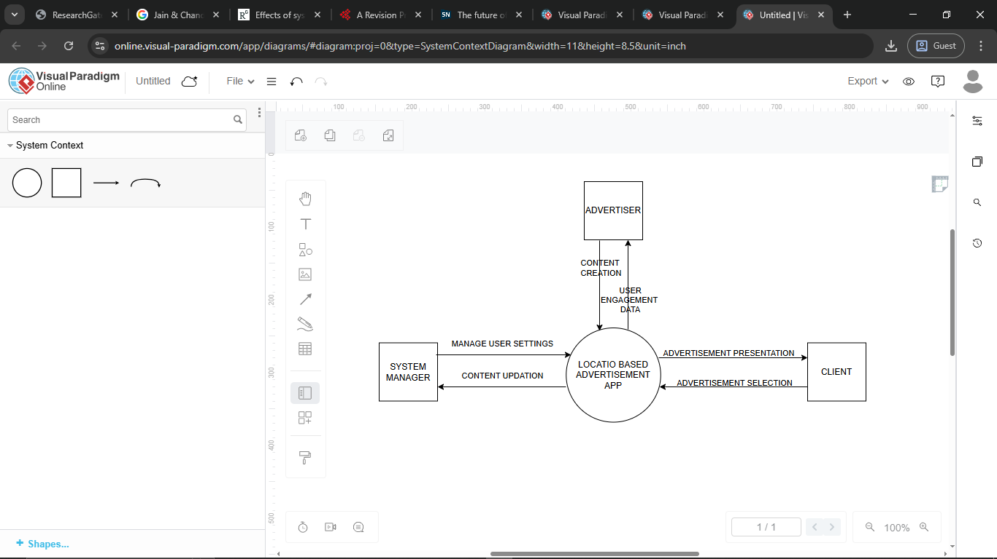

Figure 1: context diagram

Central Entity: Location-Based Advertisement App (LBAA) which is depicted in the diagram as a circle in the Centre.

External Entities:

Users: Represented by a rectangle, symbolizing the individuals using the LBAA to discover nearby products, services, and points of interest. Users will interact with the app by providing location data, searching for recommendations, and potentially engaging with advertisements.

**Advertisement Providers:** A rectangle representing businesses or organizations that pays to advertise their products or services through the LBAA platform. They will provide the app with advertisement content and potentially user targeting criteria.

System manager: this represents those who create and update the application for the users’ maximum satisfaction.

Data Flows:

Users to LBAA

In this data flow the user provides the location to which he/she is in so that the app can access it and show them the products available in their vicinity. It also shows that the user has the ability to toggle between products, enter search terms or browse categories within the LBAA to find desired products, services, or points of interest.

LBAA to users

In this particular flow of data the app will send users personalized recommendations for products, services, or points of interest based on their location, search queries, and potentially user preferences. It will also display advertisements from relevant businesses or organizations based on user location and search queries.

Advertisers to LBAA

This signifies the advertisers of various products and services submitting their advertisement content, visuals, and potentially user targeting criteria to the LBAA platform.

LBAA to advertisers

This signifies the potential for the LBAA to share anonymized user engagement data including ad clicks, impressions among others with advertisement providers to measure campaign effectiveness.

To sum it all up, the context diagram illustrates the LBAA as a platform that connects users with relevant advertisements and recommendations based on their location and preferences. It highlights the interactions between the app, users, advertisement providers, and potentially content providers. This collaborative data exchange allows the LBAA to deliver a personalized user experience while providing a platform for businesses to reach potential customers.

## USE CASE DIAGRAM

A use case diagram represents the functional interactions between the LBAA and the actors, that being users and external systems that interact with it. Below is a diagram to put it to context.

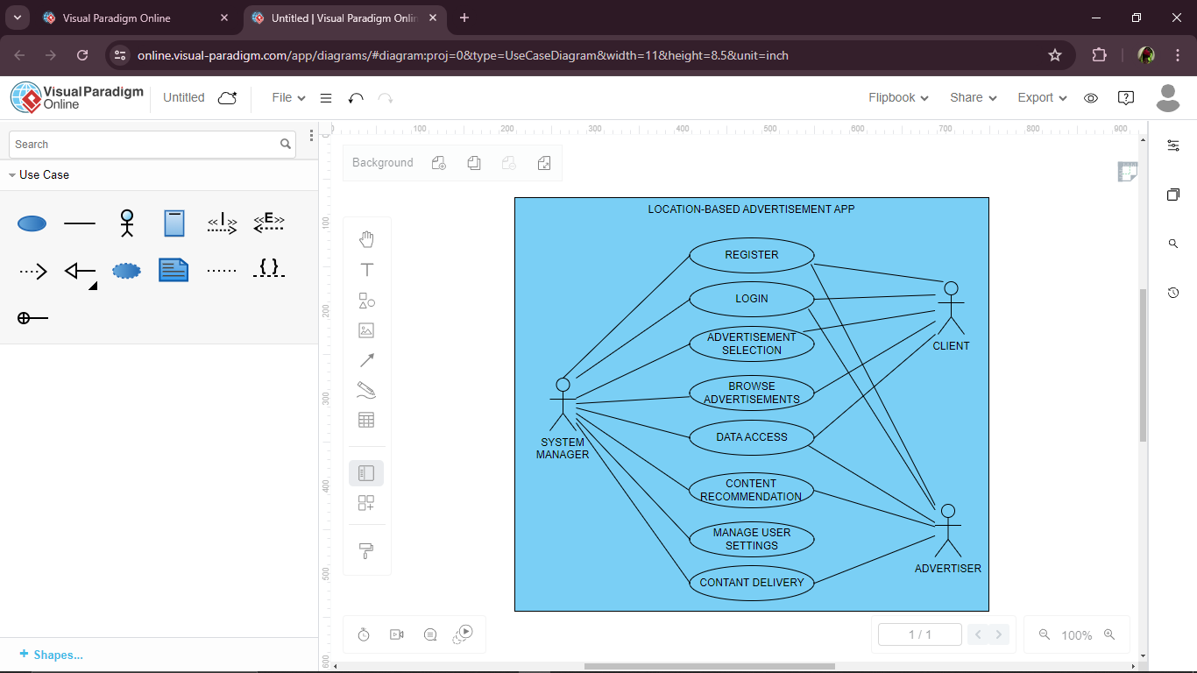

Figure 2: use case diagram

## DATA FLOW DIAGRAM (D.F.D)

A data flow diagram illustrates the flow of information within a system, in this a Location-Based Advertisement app. The diagram below is a D.F.D showing the flow of data in a LBAA:

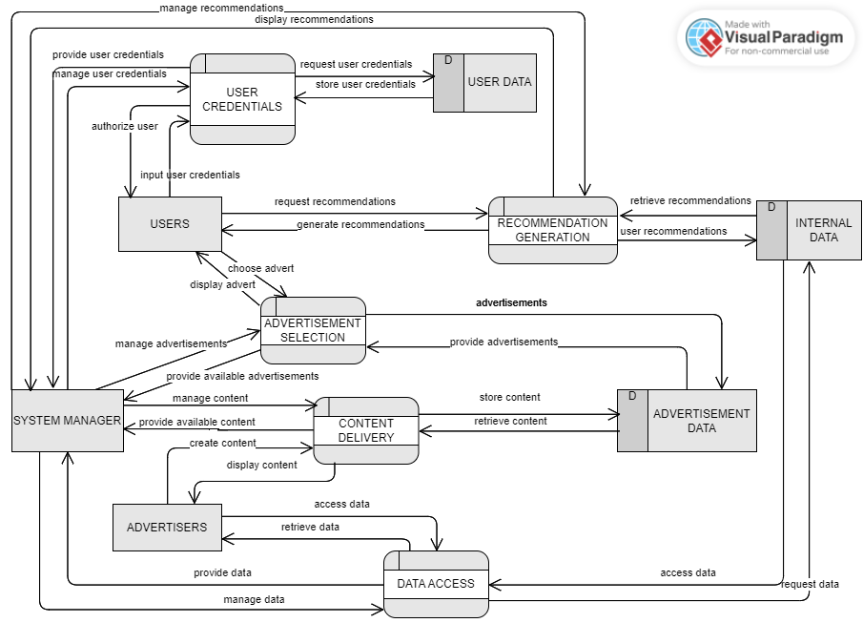

Figure 3: a data flow diagram

This is a clear illustration of the diagram.

External entities

Users: These are people who go ahead to access the app.

System Manager: This entity manages the running if the app.

Advertisers: these are entities that access the app in order to advertise their products and services to the users.

Processes

User input process captures the user interactions with the app, data access retrieves relevant data for recommendation generation while recommendation generation analyzes user data and retrieved information and advertisement generation selects appropriate advertisement to display to users based on their location and recommendation context. Content delivery on the other hand delivers personalized recommendations and targeted advertisements to the users.

Data stores

User data: Stores user information such as location history and potentially user preferences.

Internal data: Stores information about points of interest, businesses, and potentially user preferences managed by the LBAA.

Advertisement data: Stores advertisement content, visuals, and targeting criteria submitted by advertisement providers.

This D.F.D provides a high-level view of how data flows within the LBAA. It highlights how user input and internal data are processed to generate personalized recommendations and select targeted advertisements for display. The DFD emphasizes the role of data storage in managing user information, internal data and advertisement content obtained with user consent.

## DATABASE DESIGN

**Users**

|  |  |  |
| --- | --- | --- |
| FIELD | DATATYPE | ILLUSTRATION |
| user_id | int | Unique identifier for each user |
| username | varchar | Username for login |
| password | varchar | Hashed password for login |

Figure 4: database design 1

**Advertisements**

|  |  |  |
| --- | --- | --- |
| FIELD | DATATYPE | ILLUSTRATION |
| ad_id | int | Unique advertisement identifier |
| Provider_id | int | Foreign key representing the advertisement provider table |
| Title | varchar | Advertisement title |
| content | text | Description of the advertised product or service |
| Image_url | varchar | URL of advertisement image |

Figure 5: database design 2

**Advertisers**

|  |  |  |
| --- | --- | --- |
| FIELD | DATATYPE | ILLUSTRATION |
| Provider_id | Int | Unique id for each advertiser |
| Company_name | varchar | Name of company providing advertisement |
| Contact_info | text | Contact information for advertisement provider |

Figure 6: database design 3

**Points of interest (POI)**

|  |  |  |
| --- | --- | --- |
| FIELD | DATATYPE | ILLUSTRATION |
| Poi_id | int | Unique identifier for each poi |
| Name | varchar | Name of POI |
| description | text | Detailed description for each POI |
| category | varchar | Category for POI |
|  |  |  |

Figure 7: database design 4

## ER DIAGRAM

The ER diagram visually represents the core entities such as users, points of interest, advertisements and how they relate to each other. The diagram below is an ER diagram representing the relationships between core entities in a location based advertisement app.

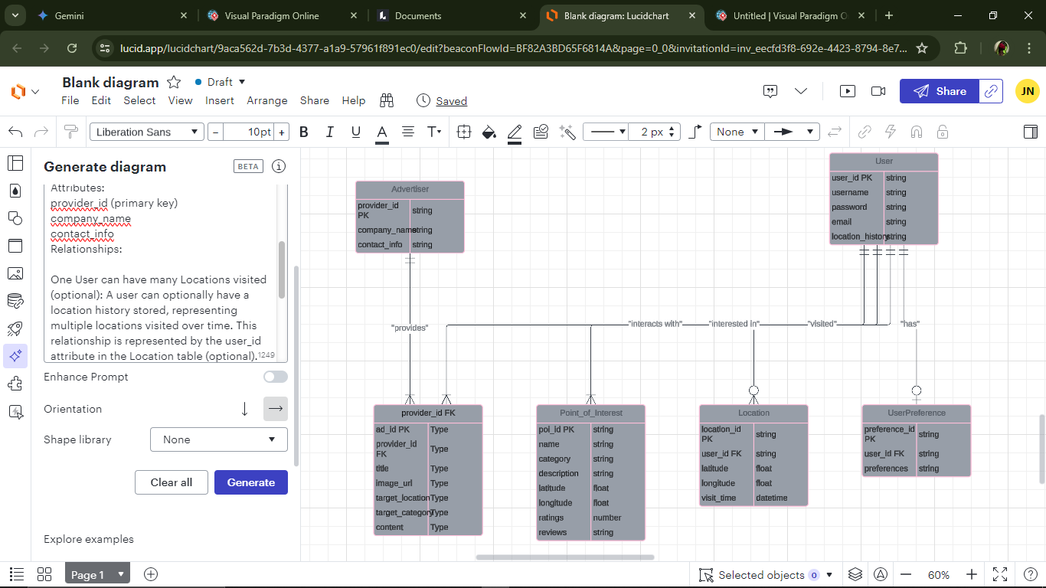

Figure 8: ER diagram

Relationships:

One User can have many Locations visited: A user can optionally have a location history stored, representing multiple locations visited over time. This relationship is represented by the user_id attribute in the Location table. He can also have many points of interests in a certain location.

Many Advertisements belong to one Advertiser**:** A single company or organization can provide multiple advertisements on the platform. This relationship is depicted by the foreign key provider_id in the Advertisement table, referencing the primary key provider_id in the Advertiser’s table.

One User can have one UserPreference:A user can optionally set preferences for recommendations within the app. This optional relationship is shown by the user_id attribute (primary key) in the UserPreference table, also acting as a foreign key referencing the Users table.

## ARCHITECTURAL DESIGN

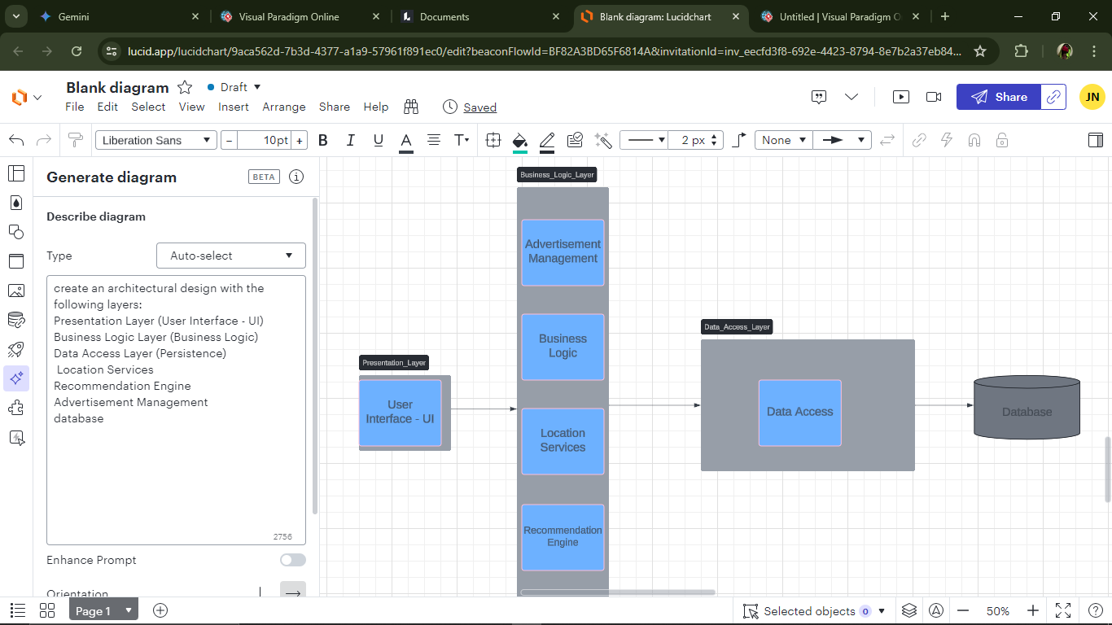

Figure 9: architectural design

## CONCLUSION

The main aim of this research proposal is to create a user-centric, location leveraging advertisement app that aids users with their endeavors whenever they come across unfamiliar/unchartered territories. As the research explored the concept, context, use cases, data flow, architecture and the database design, conclusions were made. Firstly, the LBAA leverages agile development principles in the goal of ensuring a user centric and iterative approach to building the application. This is so as to allow continuous feedback and improvements throughout the development process. In addition to that, the app functions by collecting user location data, enabling users to search for recommendations, and displaying personalized advertisements based on user context and potentially user preferences. To top it all off, data security and user privacy are paramount considerations. Secure storage, anonymization of user data, and transparent user consent practices are essential for building trust with users. The chosen architecture leverages various technologies to create a scalable and efficient system. Cloud-based solutions and containerization can facilitate future growth and maintainability and lastly, the database design provides a foundation for storing user information, points of interest, advertisements, and potentially user preferences. It emphasizes the importance of geospatial indexing and tailoring the data model to your specific functionalities.

Overall, this exploration has provided a better understanding of the road map for developing the Location-Based Advertisement Application. By following the chosen development approach, that is the agile approach, focusing on user needs and implementing a secure and scalable architecture, the research aims to create a valuable location-based advertising platform that benefits not only from the businesses in need of advertising their products in the application but also for the users who look to get a clear familiarity with the surroundings to enable them to have a clear picture of where to go in case they are in need of necessities.

# CHAPTER FOUR

# SYSTEM IMPLEMENTATION AND DEPLOYMENT

## INTRODUCTION

This chapter will provide a detailed account of the system’s development and deployment process, this including the programming languages, tools, and methodologies employed in the development process. It also points out the finalized system, not forgetting the user guide that will allow for easy navigation by users in case of acquisition.

## DEVEVELOPMENT AND SOFTWARE SETUP

**Tools employed in the development process**

Front-end: Flutter- I used flutter due to the fact that it can be used to develop cross-platform applications from a single codebase for the web, android, iOS, Linus among others. The primary language I’ve used in writing of the code is dart which is an object oriented language known for being client optimized.

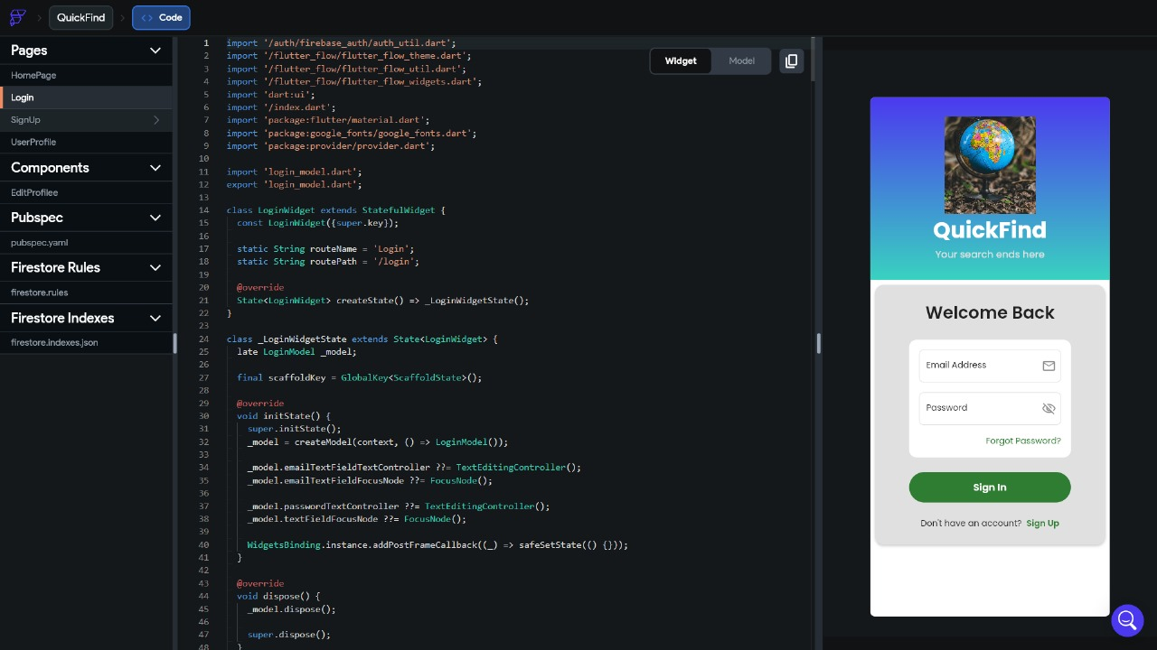

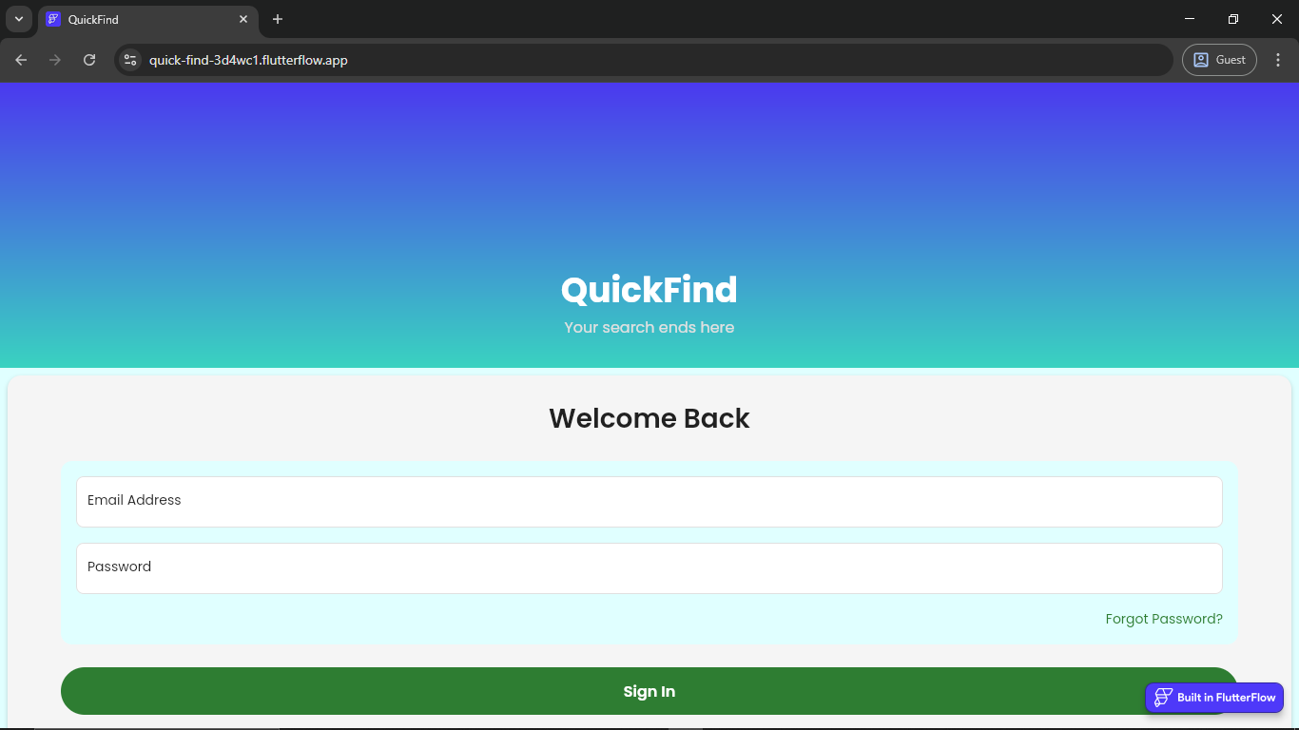

Figure 10: login page

Database: in my database I used cloud firestore which is a flexible, scalable and noSQL document-based database part of the firebase and Google cloud platforms.

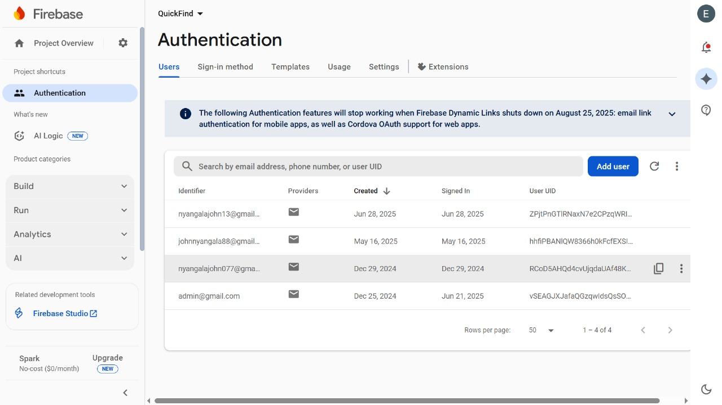

Figure 11: firestore database

The reason as to why I chose firebase as my preferred database management system was due to the fact that it collects and organizes data into documents and collections. A collection is a container for documents while the documents contain complex data types including nested objects and even sub collections allowing for hierarchical data structures.

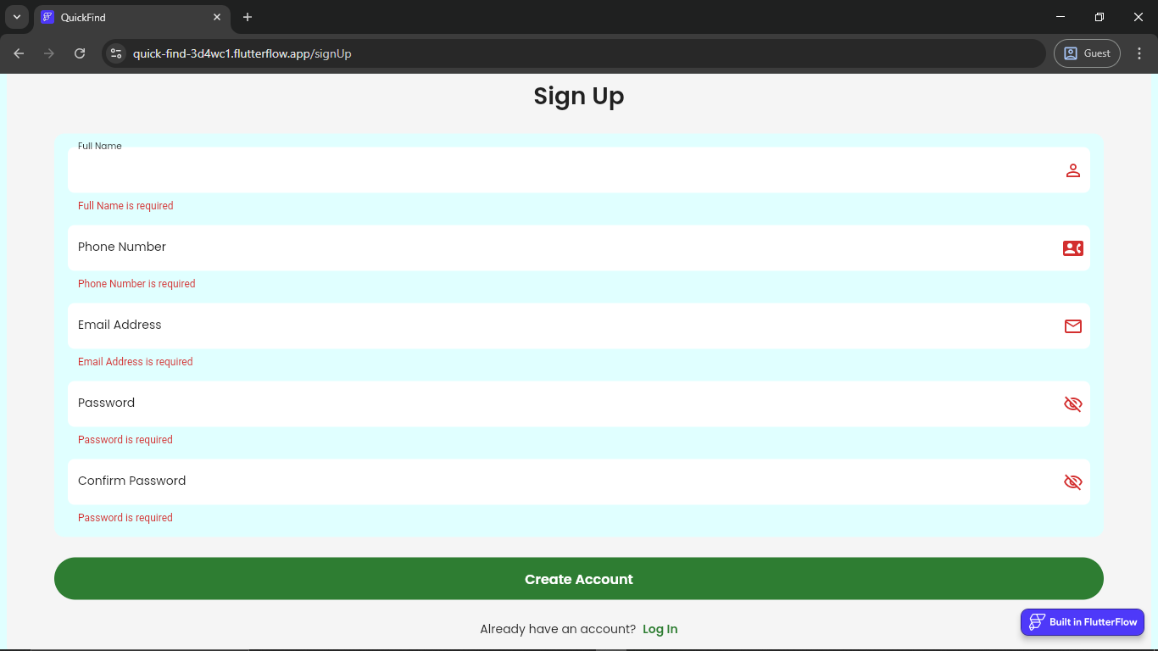

Map API: I integrated Google map API into my home page which allows me to embed interactive maps which then allow the user to search for places, get directions among others within the application.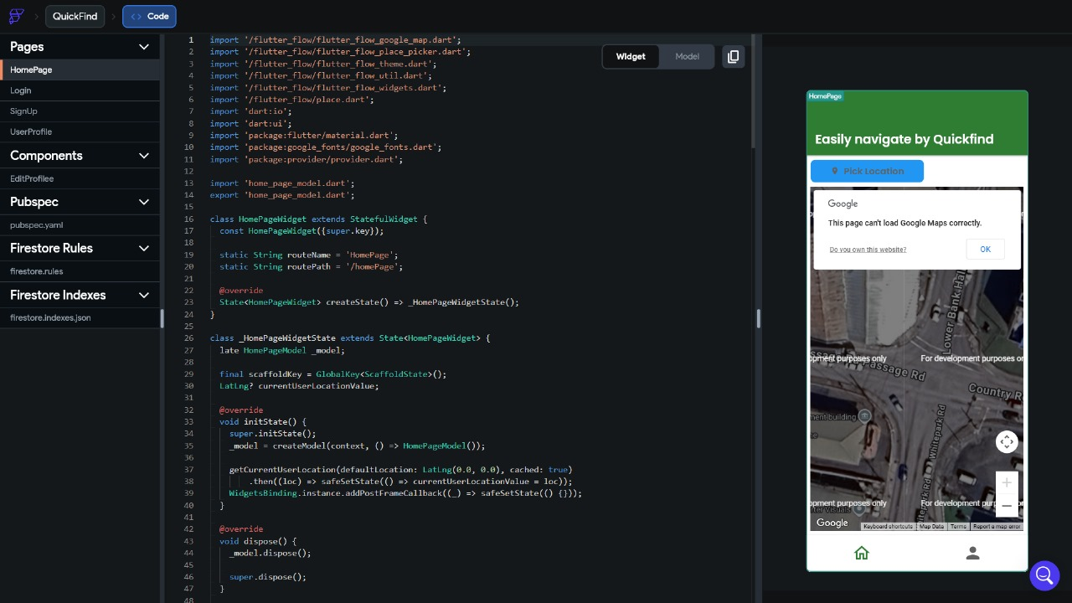

Figure 13: home page

## IMPLEMENTATION STEPS

## Step-by-step implementation plan.

## The system was implemented by following the steps below:

1st stage: User interface design and frame working

2nd stage: front end development**.**

3rd stage: Backend development and map integration.

4th stage: database design and integration.

5th stage: data analysis, running of tests and debugging.

**Code standards and practices.**

Code organization- breaking down codes in to smaller and more manageable pieces ensures a tidiness and ease of code retrieval.

Code formatting- there was use of consistent number of space and tabs. I also set a maximum number of line length to avoid horizontal scrolling.

Design principles- I adhered to the fundamental software design concepts by avoiding redundant code. I also used try-catch blocks to gracefully manage exceptions and provide meaningful error messages.

**Frontend implementation tasks**

By using flutter flow, it is much easier to build the flutter framework as it is particularly focused on frontend allowing you to design and build user interfaces with drag-and –drop interfaces, drastically reducing the need for manual coding.

**Back end implementation tasks**

I set up firebase as the backend to be able to handle user authentication and storage of data. I used firestore so as to easily retrieve tasks and allow for long term storage in real time.

### TESTING AND QUALITY ASSURANCE

Used the following tests strategies for quality assurance:

System simulation: tested the full user journey and experience while navigating the application to ensure that all run smoothly.

Checked if the database in use was in good connection with the application and handled user data with the outmost routine care.

Run the frontend separately to better make sure that the user interface was running efficiently.

### DEPLOYMENT PLAN

The application was deployed using the firebase hosting and this ensured that it was easily accessible to those who would prefer web platforms and those who would prefer mobile platforms.

### GO-LIVE PLAN

All of the applications main functions were better tested to make sure everything was running in place before launch.

### MAINTAINANCE AND SUPPORT

Reviews were done in intervals to make sure that the application was running smoothly.

## CONCLUSIONS AND FUTURE WORKS

### Conclusions

A location-based advertisement app, successfully implemented, leverages the power of geofencing and user location data to deliver highly relevant and timely advertisements. The core conclusion is that this approach significantly enhances the effectiveness of advertising by moving from a broad-cast model to a context-aware, personalized one. The application's success hinges on a robust backend infrastructure (database, authentication, and a location-aware API) and a responsive, intuitive frontend.

Specifically, the key takeaways from the implementation would be:

**Relevance Drives Engagement:** By serving ads based on a user's proximity to a store or a point of interest, the app achieves a higher click-through rate and conversion compared to generic advertising.

**Privacy is Paramount:** User trust is a critical factor. The app's success depends on a transparent and secure handling of user location data, with clear opt-in and opt-out mechanisms.

**Performance is Non-Negotiable:** Real-time geofencing and ad serving require a high-performance database and an optimized frontend. Delays in ad delivery or a sluggish user interface can lead to poor user experience and uninstallation.

**Scalability is a Key Challenge:** As the user base grows, the system must be able to handle a massive volume of location data and ad requests. The choice of a scalable backend-as-a-service (BaaS) like Firebase and an efficient database like Firestore proves to be a strategic decision for managing this growth.

In summary, the project demonstrates that a carefully designed and implemented location-based ad app can create a mutually beneficial ecosystem for both advertisers (by delivering targeted ads) and users (by receiving relevant information and offers).

### Future Works

The current implementation serves as a strong foundation, but there is significant scope for expansion and improvement. Future works should focus on enhancing the user experience, increasing advertiser value, and scaling the platform's capabilities.

**Advanced Targeting and Personalization:**

**User Behavior Analysis:** Implement machine learning algorithms to analyze user movement patterns, app usage, and ad interactions. This would enable the app to predict user interests and serve ads that are relevant not just to their current location but also to their historical behavior.

**Time-Based Offers:** Introduce the ability for advertisers to schedule ads and offers based on time of day (e.g., lunch specials from 12 PM to 2 PM), creating a sense of urgency and increasing foot traffic.

**Weather and Event Context:** Integrate weather data and local event calendars to serve even more context-aware advertisements. For example, promoting an umbrella store on a rainy day or a coffee shop near a concert venue.

**Enhanced User Experience and Features:**

**Augmented Reality (AR) Integration:** Allow users to view a map of nearby stores and offers overlaid on a live camera feed. This could create an interactive and engaging way to discover new places.

**Gamification:** Introduce a loyalty program or a points system where users can earn rewards for visiting stores or interacting with advertisements. This would encourage app usage and customer retention.

**Improved Notifications:** Implement smarter, non-intrusive notifications. Use A/B testing on notification timing and content to optimize engagement without annoying the user.

**Platform and Advertiser Tools:**

**Self-Service Advertiser Portal:** Develop a web-based portal that allows advertisers to manage their own campaigns, set up geofences, upload ad creatives, and view real-time analytics and performance metrics.

**API for Third-Party Integration:** Create a public API that allows other applications and services to integrate with our ad platform, opening up new channels for ad distribution and revenue streams.

**Dynamic Pricing and Bidding:** Introduce a dynamic pricing model where advertisers can bid for ad placements in high-traffic or highly sought-after geofenced areas, similar to how traditional online ad exchanges work.

**Technical and Architectural Improvements:**

**Scaling the Backend:** As the user base grows, migrate to more sophisticated, purpose-built cloud services for location data processing. Explore services like Google Cloud's BigQuery for advanced data analysis and machine learning.

**Offline Mode:** Implement robust offline capabilities to ensure that the app remains functional even in areas with poor network connectivity, caching geofenced areas and relevant ads.

**Cross-Platform Expansion:** Continue to refine and optimize the application for new platforms such as desktop and embedded systems, leveraging the cross-platform nature of Flutter.

REFERENCE

Adomavicius, G., & Tuzhilin, A. (2005). Toward the next generation of recommender systems: a survey of the state-of-the-art and possible extensions. *IEEE Transactions on Knowledge and Data Engineering*, *17*(6), 734–749. <https://doi.org/10.1109/tkde.2005.99>

Park, N., & Lee, S. (2014). College students' motivations for Facebook use and psychological outcomes. Journal of Broadcasting & Electronic Media, 58(4), 601–620. [https://doi.org/10.1080/08838151.2014.966355](https://psycnet.apa.org/doi/10.1080/08838151.2014.966355)

‌ Jannach, D., Zanker, M., & Fuchs, M. (2014). Leveraging multi-criteria customer feedback for satisfaction analysis and improved recommendations. *Information Technology & Tourism*, *14*(2), 119–149. <https://doi.org/10.1007/s40558-014-0010-z>

Grewal, D., Hulland, J., Kopalle, P. K., & Karahanna, E. (2020). The future of technology and marketing: A multidisciplinary perspective. *Journal of the Academy of Marketing Science*, *48*(1), 1–8. springer. <https://link.springer.com/article/10.1007/s11747-019-00711-4>

‌ Guyon, I., Elisseeff, A., & Kaelbling, L. P. (Ed.). (2003). An introduction to variable and feature selection. Journal of Machine Learning Research, 3(7-8), 1157–1182. [https://doi.org/10.1162/153244303322753616](https://psycnet.apa.org/doi/10.1162/153244303322753616)

Stroud, L., Green, E., & Cronje, J. (2020). A Revision Process That Bridges Qualitative and Quantitative Assessment. *Psychology*, *11*(3), 436–444. <https://doi.org/10.4236/psych.2020.113029>

Brooke, J. B., & Duncan, K. D. (1981). Effects of system display format on performance in a fault location task. *Ergonomics*, *24*(3), 175–189. <https://doi.org/10.1080/00140138108559232>

# APPENDICES

Appendix 1: Gantt chart

|  |  |  |  |  |  |  |  |
| --- | --- | --- | --- | --- | --- | --- | --- |
| No | Activity | 10th June 2024 | 11th June – 1st July | 2nd July – 11th July |  | 13th July – 31st July | 5th August 2025 |
| 1. | Project proposal approval |  |  |  | |  |  |
| 2. | Chapter 1 presentation: Introduction |  |  |  | |  |  |
| 3. | Chapter 2  Presentation: Literature Review |  |  |  | |  |  |
| 4. | Chapter 3 presentation: Research Design and Methodology |  |  |  | |  |  |
| 5. | Documentation &  Presentation |  |  |  | |  |  |
| 6 | Chapter 4 and system presentation |  |  |  | |  |  |

Appendix 2: Budget

|  |  |  |
| --- | --- | --- |
| ITEM | quantity | COST(ksh) |
| Website subscriptions | n/a | 200 |
| Internet | Per month | 1500 |
| Printing | Ksh5 per paper | 305 |
| Google maps subscription | Per session | 2500 |
| TOTAL |  | 4505 |